**P1- Evaluation**

**Question 1 :**

Program for Tower of Hanoi Algorithm (Implement in Python)

Tower of Hanoi is a mathematical puzzle where we have three rods (A, B, and C) and N disks. Initially, all the disks are stacked in decreasing value of diameter i.e., the smallest disk is placed on the top and they are on rod A. The objective of the puzzle is to move the entire stack to another rod (here considered C), obeying the following simple rules:

Only one disk can be moved at a time.

Each move consists of taking the upper disk from one of the stacks and placing it on top of another stack i.e. a disk can only be moved if it is the uppermost disk on a stack.

No disk may be placed on top of a smaller disk.

**Solution:**

def tower_of_hanoi(n, source, destination, auxiliary):

    if n > 0:

        tower_of_hanoi(n-1, source, auxiliary, destination)

        print(f"Move disk {n} from {source} to {destination}")

        tower_of_hanoi(n-1, auxiliary, destination, source)

'''

Example usage considering

source -> a

destination -> c

auxiliary -> b

'''

n = 3

tower_of_hanoi(n, 'A', 'C', 'B')

Output

For n = 3

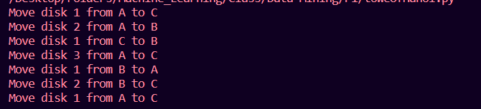

For n = 2

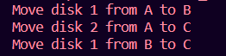

**Question 2:**   
Implement Random Forest Algorithm for the regression problem of the given dataset.

**Solution**

import pandas as pd  
from sklearn.ensemble import RandomForestRegressor  
from sklearn.model_selection import train_test_split  
from sklearn.metrics import mean_squared_error

data = pd.read_excel('dataset.xlsx')  
data.head()

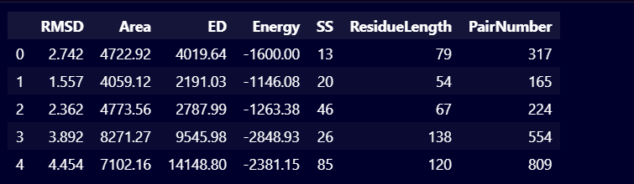

X = data.drop('RMSD', axis=1)  
y = data['RMSD']

X_train, X_test, y_train, y_test = train_test_split(X, y, test_size=0.3, random_state=90)  
print(X_train.shape)  
print(X_test.shape)  
print(y_train.shape)  
print(y_test.shape)

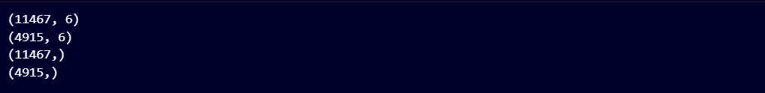

rf = RandomForestRegressor()  
rf.fit(X_train, y_train)  
y_pred = rf.predict(X_test)

from sklearn.metrics import mean_absolute_error

mse = mean_squared_error(y_test, y_pred)

print("Mean Squared Error:", mse)

mae = mean_absolute_error(y_test, y_pred)

print("Mean Absolute Error:", mae)



from sklearn.model_selection import GridSearchCV

param_grid = {

    'n_estimators': [100, 200, 300, 400, 500],

    'max_depth': [None, 10, 20, 30, 40, 50],

}

rf = RandomForestRegressor()

grid_search = GridSearchCV(estimator = rf, param_grid = param_grid,

                           cv = 3, n_jobs = -1, verbose = 2)

grid_search.fit(X_train, y_train)

best_params = grid_search.best_params_

best_rf = RandomForestRegressor(**best_params)

best_rf.fit(X_train, y_train)

y_pred = best_rf.predict(X_test)

mse = mean_squared_error(y_test, y_pred)

print('Mean Squared Error:', mse)

